**PROJECT MANAGEMENT PLAN**

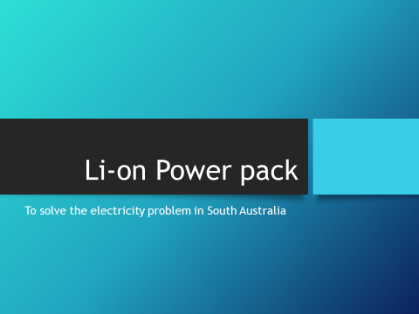**TESLA’S INITIATIVE OF POWER PLANT AT HORNSDALE WIND FARM**

# Executive Summary

South Australia (SA) suffered a statewide blackout a few years back. The power supply by the Government was not sufficient in order to fulfill the national demand. As a result, the summer period witnessed power cuts in many regions of SA and hence, there has been an utmost need for resolving such issue as soon as possible. Since the issue is of national Interest, the SA Government has taken this issue quite seriously and hence there have been number of tenders by the private parties and corporate houses for establishment of power generation plants with the public-private partnership (PPP) mode or totally through the privatization mode.

In the given context, the power giant Tesla has come forward with their proposal of establishing a power plant with a very short span of time and it has been assured by the management of Tesla that such plant will be able to fulfill the power need of entire SA. The given project report provides a brief overview of the various aspects of project management of power plant at The Hornsdale Wind Farm at SA.

Table of Contents

Executive Summary 1

1.0 Integration Management 4

2.0 Scope Management 7

3.0 Stakeholder Management 8

4.0 Schedule Management 11

5.0 Cost Management 12

6.0 Quality Management 13

Quality Standards 13

Metrics 13

Problem Reporting and Corrective Action Process 14

Supplier Quality and Control 15

7.0 Resource Management: 16

8.0 Communication Management 17

9.0 Risk Management 18

10.0 Procurement Management Plan 19

Guidelines on Types of Contracts: 19

Standard procurement documents or templates: 19

Guidelines for creating procurement documents: 20

11.0 Conclusion 21

References 21

# 1.0 Integration Management

**1.1 Project Overview**

* The primary purpose of the project is to provide world's best battery storage facility to the client to balance the South Australian electricity grid, assist integration of renewable energy in the state and help in preventing load shedding events.
* A portion of the battery will also be dedicated to trading on the electricity market. This capacity will be used to store power from the Hornsdale Wind Farm when demand is low and dispatch it when demand is high, reducing the need for expensive gas ‘peaking plants’ and placing downward pressure on power prices for South Australian consumers
* At 100MW/129MWh, the Hornsdale Power Reserve is the largest lithium-ion battery in the world. When dispatching at peak output, the battery provides enough electricity to power the equivalent of 30,000 homes.
* The battery is privately owned by Neoen in partnership with Tesla. In normal circumstances, the battery will be charged with power from the nearby Hornsdale wind farm when power is plentiful and cheap.
* The operators will then have the right to sell some of it back into the grid when the supply-demand balance is tighter, and prices are higher.
* The client will be able to use a portion of the battery's output to provide stability services to the grid.

**1.2 Project Goal**

* The project goal may be defined to be the creation of battery storage facility for SA region so that the nation does not suffer from a crisis of power cut. In addition, as stated earlier, the project will envisage the utilization and integration of renewable energy for the state.

**1.3 Project Objective**

The objectives of the project may be enumerated briefly as below:

* To provide an output of 100 megawatts of power at a time
* To produce enough energy to power about 30,000 homes for more than an hour
* To provide emergency backup power if a shortfall in energy is predicted.

In this context, it may be noted that the immense battery will be efficient to store 129-megawatt hours of energy so, if used at full capacity, it would be able to give its maximum output for more than an hour. It is conceived that this is the beginning of the transformation to next-generation renewable technology.

The battery would primarily provide stability for the power grid, domain of coal gas and hydro. It has been estimated that the Tesla battery will run at full power for about one hour and twenty minutes. In addition, it will keep the lights on during a 45-degree day in Adelaide.

**1.4 Project Deliverable**

The project will have the following deliverables:

* An array of lithium-ion batteries will be connected to the Hornsdale wind farm, which is currently under construction in SA. It will look like a field of boxes, each housing Tesla commercial-scale Power pack batteries.
* It will be a modular network, with each Power pack about the size of a large fridge at 2.1 meters tall, 1.3m long and 0.8m wide. They weigh in at 1,200 kilograms each.
* However, it has been observed that The Australian Energy Market Operator (AEMO) released an initial report a few months back on the performance of the 129MWh Hornsdale battery system that was installed by Tesla last November. It seems the market operator is pleased with the new battery, writing that the service provided by the battery system "is rapid and precise, compared to the service typically provided by a conventional synchronous generation unit."

Australian Energy Market Operator (AEMO) shared a graph showing how quickly the Tesla battery responded to the 689MW plant trip. As frequency declines, the battery starts feeding power to the grid.

The battery would primarily provide stability for the power grid, domain of coal gas and hydro. It has been estimated that the Tesla battery will run at full power for about one hour and twenty minutes. In addition, it will keep the lights on during a 45-degree day in Adelaide.

# 2.0 Scope Management

The primary purpose of the project is to provide world's best battery storage facility to balance the South Australian electricity grid, assist integration of renewable energy in the state. At 100MW/129MWh, the Horns dale Power Reserve is the largest lithium-ion battery in the world.

**Product Characteristics and Requirements:**

1. The project will utilize the existing resources with the help of contract value.
2. Tesla will need to buy the necessary equipment, machinery, and other necessary assets to set up the battery storage ("Tesla battery boss: We can solve client's power woes in 100 days", 2018).

However, the technological intervention will be crucial factors as the plant will require a significant amount of technologically sound set up and related pieces of machinery.

**Summary of Project Deliverables**

**Project management-related deliverables:** business case, charter, team contract, scope statement, WBS, schedule, cost baseline, status reports, final project presentation, final project report, lessons-learned report, and any other documents required to manage the project.

**Product-related deliverables:** research reports, design documents, software code, hardware, etc.

1. An array of lithium-ion batteries will be connected to the Horns dale wind farm, which is currently under construction in SA.
2. It will look like a field of boxes, each housing Tesla commercial-scale Power pack batteries.
3. It will be a modular network, with each Power pack about the size of a large fridge at 2.1 meters tall, 1.3m long and 0.8m wide. They weigh in at 1,200 kilograms each.

# 3.0 Stakeholder Management

|  |  |  |  |
| --- | --- | --- | --- |
| **Name** | **Level of Interest** | **Level of Influence** | **Potential Management Strategies** |
| Himaja Parachuri | High | High | Himaja is the project manager, and she needs to be kept up to date on everything that is going on in the project. She has a lot of experience dealing with problems and is very easy to work with. |
| Raghavendra Reddy | High | High | Raghavendra is a resource manager he is very good at resource planning and allocation; he is very helpful in hiring new employees and he is accountable for the overall delivery of the project. |
| Venkata Gopi Siva Sai Nallapati | High | High | Sai Nallapati is a functional manager his role is to propose projects and monitors project performance and he is also good at using resources to execute projects. |
| SaiKumar Mylavarapu | High | High | SaiKumar is business analyst where he is responsible for investigating business systems and he is good at Identifying options for improving business systems and he is also good at bridging the needs of the business with the use of IT. |
| Nagateja Neerukonda | High | High | Nagateja is electrical engineer he is good at designing, developing, testing, and supervising the manufacturing. He is also responsible for developing and implementing systems that use electricity. |
| Dr.  Aziz Fellah | High | high | Aziz Fellah is the client for the application and keeping him satisfied is the most important thing for the project. He is usually concerned about adhering the deadlines and the team needs to inform him earlier when there is a need to extend deadlines. |
| Alex Tuffin | Medium | Medium | Alex is the manager for the NEON company which is the renewable energy company mainly active in solar power and wind power, he is usually the most involved with the team and he needs to be reported about everything that’s happening in the project. |
| Mike Hulls | High | High | Mike is a senior engineer for AEMO (Australian Energy Market Operator), his role is to perform quality control, communicate with the team and he is very good at assigning responsibilities. |
| Adam Rugger | High | High | Adam is supplier manager from Electra Net(Australian Energy Market Operator) where he is responsible for ensuring that value for money is obtained from all suppliers. He makes sure that contracts with suppliers support the needs of the business, and that all suppliers meet their contractual commitments. |
| Tom Halls | High | High | Tom is a client manager for the project, he is usually the most involved with the team and he needs to be reported about everything that’s happening in the project. Keeping him happy is equally important. |

# 4.0 Schedule Management

* The interests and expectations of all the related parties must be strategically aligned with the project goals so that all the aims and objectives are in line with that of the project aims and objectives.
* A stakeholder register is maintained which includes basic information of all the stake holders.
* Cost, Time and Scope of the project is given high importance and guidelines are provided on how to balance the triple constraint.

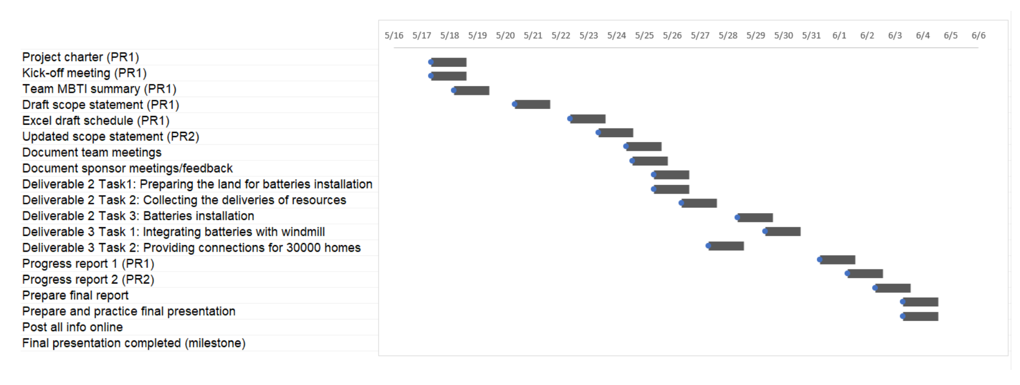

# 5.0 Cost Management

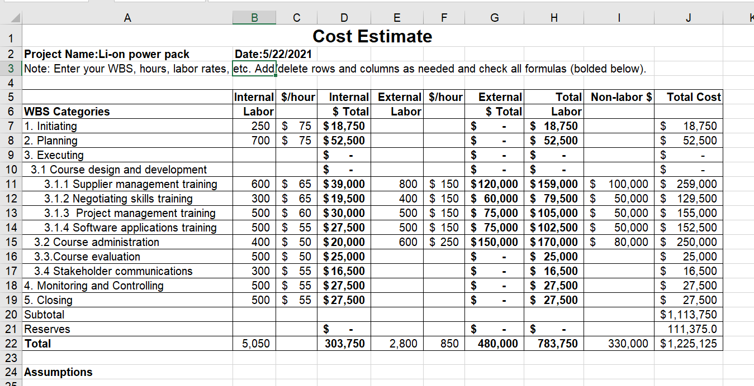

* Industry suggestions published by Forbes claimed that the 100MW battery farm would cost between $1Million to $1.5 Million.
* The management of Tesla asserted that the project would fall well within the $1.0 million set aside for renewable energy alternatives.
* According to another estimate, the price for batteries may be around $ 250-kilowatt hours in order to make it profitable .
* The price will initially be in the range of $400 to $600 kWh which would put the cost of the 100 MWh system at around $1.5 million.
* The assessment revealed that the project’s cost would start at around $0.5 million.

# 6.0 Quality Management

Project quality management ensures the project will satisfy the needs for which it was undertaken. A quality management plan includes the following:

* Determining the clients' quality goals assisting clients in expressing their quality requirements in quantifiable, objective language.
* Determining legal, environmental, economic, code, life safety, and health professional criteria. Customers' and stakeholders' expectations must be balanced against cost, time, and professional standards.
* Examining the costs and advantages of various quality objectives, as well as the techniques that will be employed to attain them.
* Meet objectives, create an effective plan and processes, including quality assurance and quality control methods. Consider the project's risk/hazard elements and complexity and adjust processes to meet the required degree of quality. Any project deviations from the local QMP criteria should be documented in the risk management strategy.
* Obtaining client approval for all quality goals set forth in the Quality Management Plan

## Quality Standards

Quality standards are set by the quality team for each department depending upon the respective work, following are the standards which are set by the team:

* A quality test is created to check the performance of each battery, which every battery should be passed before installation.
* Failure rates of the batteries is monitored to mitigate the wastage of the resources.
* Availability of charging the batteries from the wind farm should be monitored frequently.

## Metrics

* **Accuracy:** The accuracy of the deliverable product should match with the intended objective as described in the requirements.
* **Consistency:** Quality consistency means the ability of an organization to bring about, dynamic quality perspective, harmonization among all employees in terms of strategy and operations, so that they share a common and uniform view of the most important areas for the company's quality program.
* **Failure rates:** The number of items failed in test as a proportion of total number of items produced or used is taken into consider.
* **Availability:** Establishing and maintaining an availability at a justifiable cost and with an efficient use of resources. Monitoring, analyzing, comprehending, and reporting on current and future service demand, resource utilization, capacity, service system performance, and service availability.
* **Response time:** The responsiveness of the project being developed should be high so that it should not fail when required most.
* **Reliability:** The reliability of the batteries is checked so that it will perform its intended function adequately for a specified period of time.

## Problem Reporting and Corrective Action Process

The following actions are undertaken to tackle failure reporting, analysis and corrective action system.

* Report the unprecedented events.
* Once the event is report, plan, schedule and perform the required repair for the event and report repair information.
* If the report information contains failure, then prioritize the corrective actions and plan implementations.
* Once the implementations are planned corrective actions are implemented.
* Track and validate corrective actions.
* Revise corrective actions if required.

## Supplier Quality and Control

A quality control plan is designed to detail out how the supplier ensures that each feature of the components meets the required specifications. The plan includes control elements such as the manufacturing process flow, process parameters, measurement methods, statistical sampling plans, work instructions, fixtures, training etc.

# 7.0 Resource Management:

The project will utilize various resources namely:

* ***Financial:*** the sanctioned amount by the Government, i.e. the project value.
* ***Human Resource:*** The personnel, staffs, management
* ***Technological:*** The highly sophisticated and advanced technologies

The project will generate following benefits:

* Low environmental impact due to the location on agricultural land with inhibited ecological value.
* Coupling with the Horns dale Wind Farm provided the high cost-effective battery charging.
* Battery components are replaceable and the circuitry should last 20 to 30 years.
* It will provide enough power for more than 30,000 homes.
* Powerwall 2 will make the storage capacity twice and it is more compact-perfect for narrow spaces that are sides of houses.
* No need of additional inverter.
* It is safe to touch with no exposed wires and hot vents.
* The lithium-ion battery is cheap and modular.
* Tesla Power Pack’s will charge using renewable energy then deliver electricity during peak hours.

# 8.0 Communication Management

The proposed project is considered to be regarded as world’s one of the biggest power plant project. As a result, the need for establishing a sound communication plan is pre-requisite for the successful execution and implementation of the project.

\ 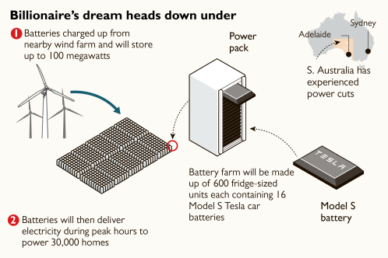

* The related stakeholders will be in constant touch with each other in order to execute the operation with greater efficiency. The Government have a frequent meeting for the purpose of assessing the growth and progress.
* The performance will be strictly monitored by the Government and any variation will be taken up with due care.
* The figure above shows that the batteries will be manufactured in a phased manner. Initially, the batteries will be charged up from the nearby wind farm and the batteries will store approximately 100 megawatts.
* Subsequently, the batteries will be delivered to nearby local power stations to generate electricity during the peak hours to power almost 30,000 homes.

In this connection, the persons responsible for successful execution of the project may be specified herein.

# 9.0 Risk Management

Every project management plan must accommodate a comprehensive risk management plan as well in order to devise the necessary risk mitigation strategy for unforeseen circumstances. In the given context, the stakeholders have different risks arising out of the given project.

* For Tesla, the reputation may be at stake if the project does not go well. The commitment of such a short time span may be vulnerable to failure. Though there have been instances that the firm has undertaken such initiatives before also and successfully executed the entire plan, the stakeholders must formulate necessary risk mitigation strategy if the project may not be deliverable within the given time frame.
* In addition, Tesla might be in a financial squeeze that limits its ability to fund.
* As far as SA Government is concerned, the Government's credibility hinges on fixing the ongoing power woes that have plagued SA. If the battery is not operating by the start of summer, South Australia might be vulnerable to blackouts in the lead-up.

# 10.0 Procurement Management Plan

## Guidelines on Types of Contracts:

Contracts for using certain commodities and services on a project are known as procurement contracts. Fixed-value, cost-reimbursable, or time-and-materials contracts are the most common types of procurement contracts. On a single purchase, certain agreements may include more than one of these payment schemes.

The executive acquisition process enables you to get the best temporary workers and service suppliers for the products and initiatives you need for your project. Because each type of procurement contract comes with its own set of benefits and downsides, choosing the right one can have a considerable impact on the success of a project.

## Standard procurement documents or templates:

* **Minor/Low Risk Contracts:** In this type of contract, an organization need administrations for a short amount of time, and the work is often tedious. As a result, top-of-the-line board methods aren't required for this type of arrangement.
* **Major/High Risk Contracts:** The labor required here is becoming increasingly difficult, necessitating the use of more advanced administration approaches.
* **Professional:** This necessitates a higher level of information-based skill, as well as directors who are willing to devote greater time and effort to finding new knowledge in order to meet the client's expectations.
* **Facilities:** Typically, the labor dispersed in this type of administration is the upkeep or activity of an existing structure or framework.
* **Local/Simple Purchases:** Goods are more readily available, and hence the board of the purchasing and delivery process is not required.
* **International/Complex Purchases:** In this case, products from several regions should be obtained. The job of an administrator is becoming increasingly taxing, and a management technique is required to purchase and deliver. Similarly, the supervisor must look into cross-border customs.

## Guidelines for creating procurement documents:

A procurement document must have a large number of reports that serve as invitations to delicate, requests for delicate foffers, and establish the terms and conditions of a contract. The purchaser's first offer and the monetarily party in question's request for concessions.

Requests for data between two gatherings, as well as requests for citations and recommendations, as well as the response of the dealer, should all be included in the procurement documentation.

1. Potential bidders must give all business specifics in order for the bidder to be evaluated.
2. In order to be evaluated, potential bidders must provide full business details.Clear meaning of the duties, rights and responsibilities of the two gatherings in the agreement.
3. The nature and character of the items or services to be provided are clearly defined.
4. Provisions that aren't biased against any party's interests.
5. The language is simple and uncomplicated.

# 11.0 Conclusion

The contract signed by the Tesla and Client has been a remarkable attempt in national energy scenario. It is needless to mention that such initiative has paved a great way to the creation of not only power but also the bigger scope for employment across the territory through various ancillary services associated with such gigantic venture. The initiative has been well supported by the relevant stakeholders including the SA Government and hence, it is expected to yield the desired value for the nation.

# References

‘More details need to come out’. (2018). Retrieved from <https://www.news.com.au/national/south-australia/confusion-over-elon-musks-battery-offer-for-south-australia/news-story/0f561d440363f4c7b50818eba86d126e>

A month in, Tesla's SA battery is surpassing expectations. (2018). Retrieved from <http://theconversation.com/a-month-in-teslas-sa-battery-is-surpassing-expectations-89770>

Bernard Lagan, S. (2018). Elon Musk builds biggest ever battery plugs city’s energy gap. Retrieved from <https://www.thetimes.co.uk/article/elon-musk-builds-biggest-ever-battery-plugs-citys-energy-gap-0nxl8svdh>

'I'll fix SA power problems in 100 days': Tesla boss Elon Musk. (2018). Retrieved from <http://www.abc.net.au/news/2017-03-10/tesla-boss-elon-musk-pledges-to-fix-sas-electricity-woes/8344084>

Megahype over tesla battery capable of providing nameplate power for less than 80 minutes. (2018). Retrieved from <https://www.forbes.com/forbes/welcome/?toURL=https://www.forbes.com/sites/rodadams/2017/07/07/megahype-over-tesla-battery-capable-of-providing-nameplate-power-for-less-than-80-minutes/&refURL=&referrer=#365e848a4919>

SA to get world's biggest lithium-ion battery in 'historic' deal with Elon Musk. (2018). Retrieved from <http://www.abc.net.au/news/2017-07-07/sa-to-get-worlds-biggest-lithium-ion-battery/8687268>

Tesla battery boss: We can solve SA's power woes in 100 days. (2018). Retrieved from <http://www.afr.com/news/tesla-battery-boss-we-can-solve-sas-power-woes-in-100-days-20170308-gut8xh>

Tesla switches on the world's biggest battery in Australia. (2018). Retrieved from <http://www.dailymail.co.uk/sciencetech/article-5135421/Tesla-switches-giant-battery-shore-Australias-grid.html>